MD. AMIRUL ISLAM
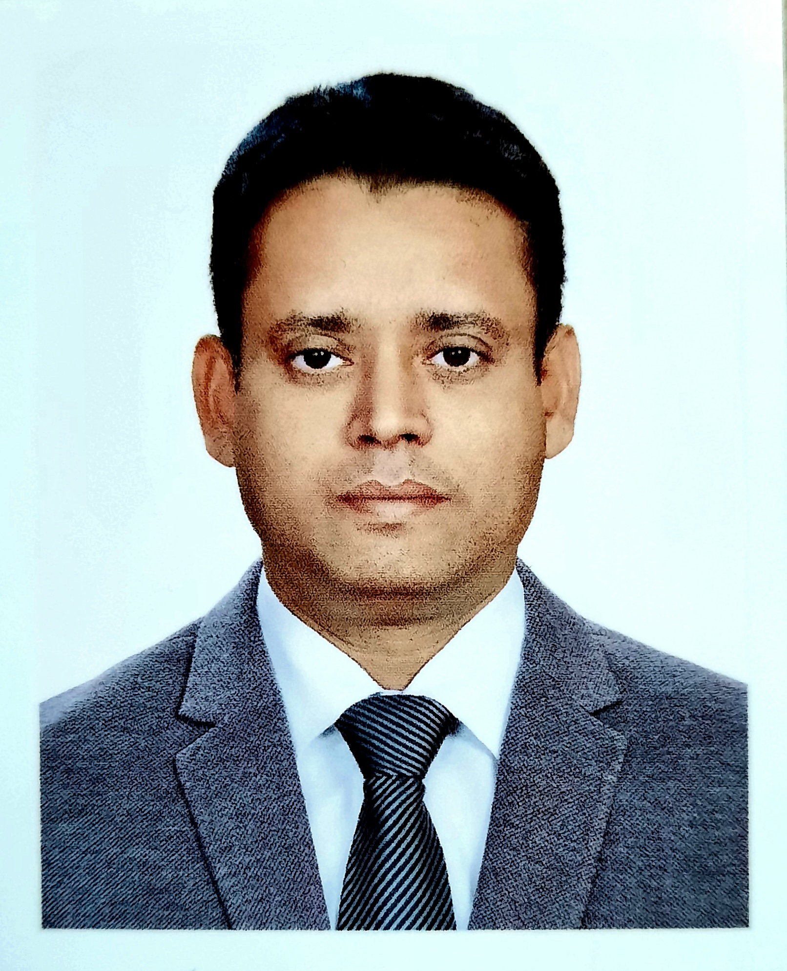

Level # 6, House # 714, Road #22, Block # F

Bashundhara Residential Area,

Dhaka-1229, Bangladesh.

Cell: +8801715 282905
Email: amirul.air@gmail.com

CAREER OBJECTIVE:

To develop a prospective career with a reputed Organization by achieving satisfactory results and success through hard work, efficiency & honesty.

PERSONAL SUMMARY:

A Supply Chain professional with years of invaluable Supply Chain knowledge of managing projects, resources and staff in an effective and efficient manner.

Committed to identify and implementing continuous improvements in the supply chain arena. Currently looking for a challenging managerial position, which will make the best use of my existing skills and experience. And also further my personal and professional development.

SKILLS:
ERP/SAP implementation & execution, Import & Custom, C&F and Freight Forwarder - Sourcing - Demand Forecasting – Purchasing & Distribution – Logistics - Inventory Management – Warehousing & Storage - Quality Management – Risk Analysis – Team Leadership - Business Development – Cost Reduction – International Trade – Vendor Management - Training & Development

EMPLOYEE:

2022 – Present

General Manager-SCM



Masud Steel Design BD Ltd.

MASUD GROUP


House # 26 Level-5, 6 & 10
Garib-E-Newaz Avenue, Sector 13, Uttara
Dhaka-1230, Bangladesh.

Responsibilities:
- Collect and verify the indent/requisitions from user.
- Prepare annual and monthly procurement plan to meet the business needs and keep a constant check on stock levels to maximize business efficiency.
- Get approval procurement plan by the management.
- Lead the sourcing, assessment & negotiation process
- Identify potential suppliers, visit existing suppliers and maintain good relationships.
- Supplier profiling, screening & selecting supplier as per specification.
- Negotiates long-term contracts to ensure optimum costs and reliable supply.
- Timely and cost-effective procurement of various materials from local and overseas sources.
- Ensures thorough and complete purchase and inventory records to provide accurate accounting of all purchased goods and services. Audit all purchases.
- Check the bills of vendors and get approval of the competent authority
- Confirm delivery of products, ensure VAT entry & payment of suppliers
- Follow up loading & unloading plan
- Check Inventory Status and report to management
- Follow up Import Plan, L/C procedure and C&F activities.
- Follow up Bonded Warehouse operation and regulatory affairs.
- Monitor software based (ERP-Enterprise Resource Planning) Inventory recording, Purchase, Delivery and Controlling system
- Monitoring data management to keep accurate product, contract, pricing and invoicing information.
- Working closely with suppliers and customers to improve operations and reduce cost.
- Ensuring the personal safety and safe working environment of staff.
- Obtaining quotes to make cost comparisons.
- Analyze the stock report and sorting out the stock positioning.
- Ensures materials are available to meet production schedules and/or products are shipped as per schedules.
- Establishes and modifies operational methods and procedures for inventory management, cycle counting and physical inventories
- Maintains documentation to support compliance, effectiveness and efficiency of department activities.
- SOP (Standard Operating System) has been established to achieve uniformity of efficiency, quality output and performance.
Any other job, as and when assigned by the competent authority,

WORK EXPERIENCES:

2012 – 2021

From 1st July 2012 to December 2021

Assistant General Manager-SCM
(Head of Supply Chain)

NIPRO JMI Company Ltd.
(A 100% Export Oriented Joint Venture Medical Devices with Japan & Korea)
Corporate Extension Office: 29/C & 29/D, Tejgaon Industrial Area,Tejgaon, Dhaka-1208.
Registered Office: 72/C , Progoti Shoroni , Middle Badda, Dhaka-1212.

2009- 2012

Manager – Purchase, Delivery & Inventory

From 10th November 2009 to 30th June 2012

Paradise Cables Ltd.

PARADISE Group
34, Awal Center, Banani, Dhaka.

2007- 2009

Deputy Manager –Warehouse & Inventory

From 1st January 2007 to October 2009



Bengal Group of Industries.
75,Gulshan-1, Dhaka.


2001- 2006

Sr. Executive (MIS & Inventory)

From August 1998 to December 2006


Excelsior Group
338, Segun Bagicha, Dhaka-1000.

ACADEMIC CREDENTIALS:

MBA Finance, Passing year: 2011, 3.64 (Equivalent 1st Class)
M.Com Marketing, Passing year: 1997, Class: Second
B.Com Passing year: 1995, Class: Second
H.S.C Passing year: 1992, Division: Second
S.S.C Passing year: 1990, Division: First

PROFESSIONAL CREDENTIALS:

PGD (Post Graduation Diploma) on SCM (Supply Chain Management) from
ISCEA (International Supply Chain Education Alliance-USA)

COMPUTER SKILLS:

Diploma in Computer
IBTI (Islami Bank Technical Institute)
MS-Word, MS-Excel, MS-Power point, Visual Fox-pro, Turbo C/C++, Hardware, Trouble Shooting, Net Working, Photoshop, Illustrator, E-mail, Internet & File Management.

STRENGTHS:

- Skilled in communication, presentation, motivation & confidence to work under stress.
- To participate in voluntary jobs like-Organize Seminar/Conference, helping flood victims, poor people, to donate blood etc.
- Able to write and speak English fluently.

OFFICIAL TRAINING

- Certified tanning on Internal Auditor from TUV SUD South Asia Pvt. Ltd.
- Short training Course on “How to deal with C&F, Shipping Line, Air Line and FF agent with Export-Import procedure” from Business Express.
- Certified training on below modules form “Academy Division of TUV SUD South Asia Pvt. Ltd.”: Risk Management, Biocompatibility, Sterility Testing & Sterilization Validation, Design Control & Process Validation.
- Completed short training course on International Accounting Standard from SELTA Training Associates. (ICMA)
- Short training on Customize Inventory Software from LED Bangladesh Limited.
- Short training Course on “L/C Procedures for Import & Export with Practical Exercise” from bdjobs training.

OTHER PERSONAL INFORMATION:

Father’s Name : Late S.M. Alam Mia
Mother’s Name : Jahanara Begum
Date of birth : 1st January 1975
Marital Status : Married

Present Address : Level # 6, House # 714, Road #22, Block # F

Bashundhara Residential Area, Dhaka-1229, Bangladesh.

Cell : +8801715 282905
E-mail : amirul.air@gmail.com
Permanent Address : House # 46/11, West Alipur, Ambikapur–1, Faridpur.

National ID : 463 131 9037

Passport No. : BL0449121

Nationality : Bangladeshi by birth.

Expectation Salary : 1,50,000 (One Lac Fifty Thousand Only)

I hereby declare that all the information’s furnished by me in this resume are true to the best of my knowledge.


(Md. Amirul Islam)

